**SARA HACHECHE** ASSIGNMENT # 6

1. **1.** On **Omnivox** in the section *Documents* you will find a document called ***Types of Software Testing,*** make the reading and:  
     
      
     
    ��� On a template or through a mind map explain in **your own words** each one of the 13 types of software testing.

1-End-to-end Testing: this is the test we do to test all the possible details on the application from start to finish

2/ User Interface Testing: the user interface test and to ensure that everything works smoothly from the first phase of development to the delivery of the product and to make its use easier

3/ Accessibility testing: this test is carried out to ensure that the application or the product is accessible to all people, even disabled people, and to ensure the best functioning

4/ Ad-hoc testing: this test is a little different from the others we use without any requirements or rules it can be difficult to find errors with it but it can always be used to find problems in the system and this type of test can be used by everyone

5/ Compatibility testing: this test is done to find out if the application is compatible and works well and verify the smallest details for a better result

6/Backward compatibility testing : this test is generally carried out when there are updates in the application and it is very important in the workplace because generally there are always changes

7/ Browser compatibility testing: this test always remains in the compatibilities it is used for the web to verify if it is easily accessible

8/ Recovery testing : in this test the testers will try to go back to see what is recoverable in the software

9/. Agile testing: this type of test is carried out by all teams according to the rules and requirements

10/ API testing: this type of test is carried out by the development team and it is a special unit test for codes

11/ Security testing: the security test is among the most important tests to ensure security in our system

12/ Scalability testing: this type of test is done to see the evolution of the application and ensure the perfect functioning of the application when it is used by several users

13/ Reliability testing: it is a type of software testing to verify that everything is reliable and working perfectly in our application and to ensure superior quality for our products

**2. Using your own words** explain the difference between *Testing Techniques* & *Types of Test*. (3 lines)

the types of tests are the different tests we have and the variety of choices we have to test a product and the techniques tested are the methods we use for each test because each test has requirements and rules to respect for its useand ensuring quality for our products is the most important thing

**3.** After checking the first slides and **using your own words** explain what *Unified Modeling Language* is*.* (3 lines)(Please **don’t** copy & paste)

A modeling language can be graphical or textual, these are techniques used either graphically or with text or with symbol parameters to make expressions interpretable by computers.

Different kinds of modeling languages are used in various disciplines:Computer science,

Information management......

**4.** Go to *Omnivox.* In the section *Documents* you will find a document called ***The UML in the Age of Agile***. Make the reading and answer the following questions *using your own words*:

A) Why despite having the agile method is UML still important? (3 or 4 lines)

despite the agile method and all its interest and technique, UML remains very important to users because it is easier and more practical and takes less time to code a new program, it has many advantages for its much success so far and it allows us to gain a lot of time and save a lot of money.

B) Explain each one of the 4 *Benefits of the UML* using your own words. (2 or 3 lines)

1. Bring New Developers or Team Members up to Speed Quickly:thanks to the diagrams and the and its easy methods it facilitates and ensures a better work for the developer during their production

2. Tailor the Elements in a UML Diagram:  
adapt all the elements of the Uml diagram for the easiest and axxcessible and we can ignore him

Plan out New Features Before Programming:this language is very important because it helps us to detect the problem before starting to work so it saves us a lot

4. Communicate with Technical and Non-Technical Audiences More Easilyfirst of all this language is very familiar and can be used easily by most people in the field and it has many advantages

C) What is *UML 2.5*? Explain it using your own words. (4 lines)

the objective of UML design is to provide a global view of the online platform. It is presented in the form of a diagram or pictograms can be used to best represent the elements of the software system and Provide system designers, software engineers and software developers with tools for analysis,

D) How does UML 2.5 work in *Structure Diagrams* and *Behavior Diagrams*? Make a comparative table with 4 differences between them.

|  |  |
| --- | --- |
| Structure diagram | Behavior diagram |
| they show different objects in a system. | diagrams show what should happen in a system |
| It describe how the objects interact with each other to create a functioning system | It describe how the objects interact with each other to create a functioning system |
| Use symbols such as boxes | Use symbols such as circles |
| Show The static behavior of the system | Show the dynamic behavior of the system |

**5**. Class Diagram Exercise: Following the last two examples given in the slides:

*Person: Student / Lecturer* and *BankAccount: CheckingAccount / SavingsAccount*

A)**Make a simple** *Class Diagram* with the following information:

*College: Student / Teacher*

B) **Make a simple** *Class Diagram* with the following information:

*Online Shopping: Customer /Order*

C) With the *Types of UML diagrams* **complete** the next simple **Class Diagram**. (Put the information inside the diagram).

**Types of UML** :

Structural Diagrams: Class Diagram, Object Diagram, Component Diagram, Composite Structure Diagram, Deployment Diagram, Package Diagram.

Dynamic Diagrams: Activity Diagram, Use Case Diagram, Interaction Overview Diagram, Timing Diagram, State Machine Diagram, Communication Diagram, Sequence Diagram.

**6. Make a simple** *Object Diagram*

A) *College: Student / Teacher*

B) *Online Shopping: Customer /Order*

**7.** Make a simple *Component Diagram* with the following information:

A) *College: Student / Teacher*

B) *Banking Account: Saving Account / Checking Account*

**8.** Explain using your own words each one of the six *Static / Structural* UML diagrams. (Please don’t copy and paste). You can make a table.

ASSIGNMENT # 6

**1.** On **Omnivox** in the section *Documents* you will find a document called ***Types of Software Testing,*** make the reading and:  
  
   
  
 ��� On a template or through a mind map explain in **your own words** each one of the 13 types of software testing.

1-End-to-end Testing: this is the test we do to test all the possible details on the application from start to finish

2/ User Interface Testing: the user interface test and to ensure that everything works smoothly from the first phase of development to the delivery of the product and to make its use easier

3/ Accessibility testing: this test is carried out to ensure that the application or the product is accessible to all people, even disabled people, and to ensure the best functioning

4/ Ad-hoc testing: this test is a little different from the others we use without any requirements or rules it can be difficult to find errors with it but it can always be used to find problems in the system and this type of test can be used by everyone

5/ Compatibility testing: this test is done to find out if the application is compatible and works well and verify the smallest details for a better result

6/Backward compatibility testing : this test is generally carried out when there are updates in the application and it is very important in the workplace because generally there are always changes

7/ Browser compatibility testing: this test always remains in the compatibilities it is used for the web to verify if it is easily accessible

8/ Recovery testing : in this test the testers will try to go back to see what is recoverable in the software

9/. Agile testing: this type of test is carried out by all teams according to the rules and requirements

10/ API testing: this type of test is carried out by the development team and it is a special unit test for codes

11/ Security testing: the security test is among the most important tests to ensure security in our system

12/ Scalability testing: this type of test is done to see the evolution of the application and ensure the perfect functioning of the application when it is used by several users

13/ Reliability testing: it is a type of software testing to verify that everything is reliable and working perfectly in our application and to ensure superior quality for our products

**2. Using your own words** explain the difference between *Testing Techniques* & *Types of Test*. (3 lines)

the types of tests are the different tests we have and the variety of choices we have to test a product and the techniques tested are the methods we use for each test because each test has requirements and rules to respect for its useand ensuring quality for our products is the most important thing

**3.** After checking the first slides and **using your own words** explain what *Unified Modeling Language* is*.* (3 lines)(Please **don’t** copy & paste)

A modeling language can be graphical or textual, these are techniques used either graphically or with text or with symbol parameters to make expressions interpretable by computers.

Different kinds of modeling languages are used in various disciplines:Computer science,

Information management......

**4.** Go to *Omnivox.* In the section *Documents* you will find a document called ***The UML in the Age of Agile***. Make the reading and answer the following questions *using your own words*:

A) Why despite having the agile method is UML still important? (3 or 4 lines)

despite the agile method and all its interest and technique, UML remains very important to users because it is easier and more practical and takes less time to code a new program, it has many advantages for its much success so far and it allows us to gain a lot of time and save a lot of money.

B) Explain each one of the 4 *Benefits of the UML* using your own words. (2 or 3 lines)

1. Bring New Developers or Team Members up to Speed Quickly:thanks to the diagrams and the and its easy methods it facilitates and ensures a better work for the developer during their production

2. Tailor the Elements in a UML Diagram:  
adapt all the elements of the Uml diagram for the easiest and axxcessible and we can ignore him

Plan out New Features Before Programming:this language is very important because it helps us to detect the problem before starting to work so it saves us a lot

4. Communicate with Technical and Non-Technical Audiences More Easilyfirst of all this language is very familiar and can be used easily by most people in the field and it has many advantages

C) What is *UML 2.5*? Explain it using your own words. (4 lines)

the objective of UML design is to provide a global view of the online platform. It is presented in the form of a diagram or pictograms can be used to best represent the elements of the software system and Provide system designers, software engineers and software developers with tools for analysis,

D) How does UML 2.5 work in *Structure Diagrams* and *Behavior Diagrams*? Make a comparative table with 4 differences between them.

|  |  |
| --- | --- |
| Structure diagram | Behavior diagram |
| they show different objects in a system. | diagrams show what should happen in a system |
| It describe how the objects interact with each other to create a functioning system | It describe how the objects interact with each other to create a functioning system |
| Use symbols such as boxes | Use symbols such as circles |
| Show The static behavior of the system | Show the dynamic behavior of the system |

**5**. Class Diagram Exercise: Following the last two examples given in the slides:

*Person: Student / Lecturer* and *BankAccount: CheckingAccount / SavingsAccount*

A)**Make a simple** *Class Diagram* with the following information:

*College: Student / Teacher*

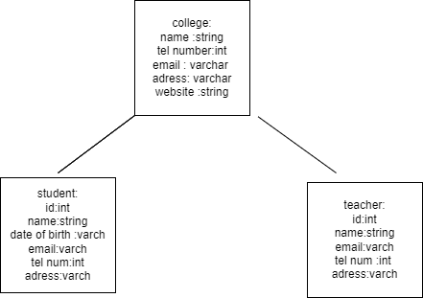

B) **Make a simple** *Class Diagram* with the following information:

*Online Shopping: Customer /Order*

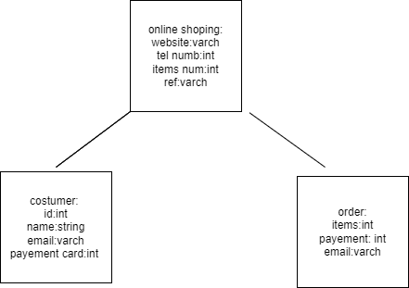

C) With the *Types of UML diagrams* **complete** the next simple **Class Diagram**. (Put the information inside the diagram).

**Types of UML** :

Structural Diagrams: Class Diagram, Object Diagram, Component Diagram, Composite Structure Diagram, Deployment Diagram, Package Diagram.

Dynamic Diagrams: Activity Diagram, Use Case Diagram, Interaction Overview Diagram, Timing Diagram, State Machine Diagram, Communication Diagram, Sequence Diagram.

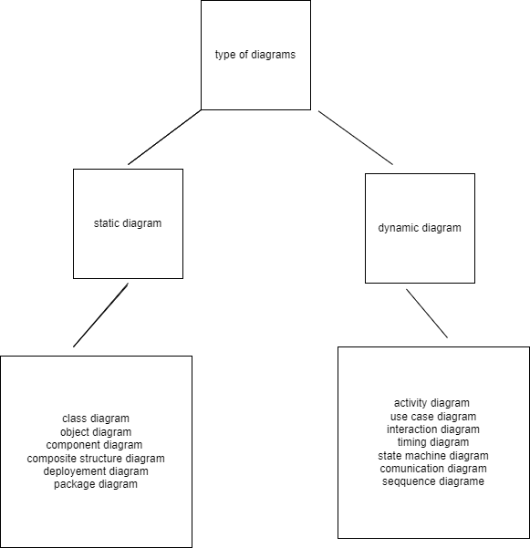

**6. Make a simple** *Object Diagram*

A) *College: Student / Teacher*

B) *Online Shopping: Customer /Order*

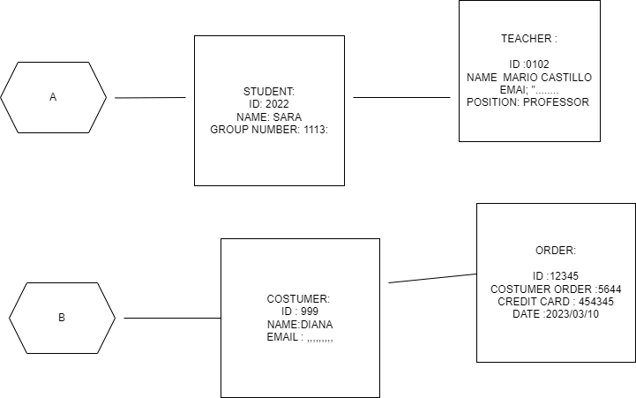

**7.** Make a simple *Component Diagram* with the following information:

A) *College: Student / Teacher*

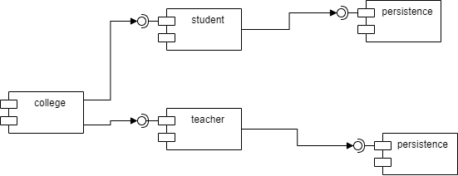

B) *Banking Account: Saving Account / Checking Account*

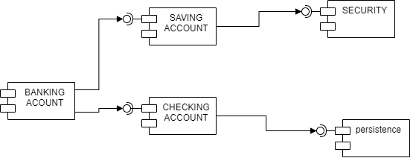

**8.** Explain using your own words each one of the six *Static / Structural* UML diagrams. (Please don’t copy and paste). You can make a table.